G                                                                  

Functional Testing Document

  VF Center

    Revision

                                                                     Version 1.0

**Document Revision History**

|  |  |  |  |
| --- | --- | --- | --- |
| **Document Version** | **Modification/Approval Date** | **Modified By** | **Section,Page(s) and Text Revised** |
| 1.0 | 30.09.2020 | Praveen Kulkarni & Susmitha | Initial Draft based on KT and documents provided by Mphasis team |
|  |  |  |  |
|  |  |  |  |
|  |  |  |  |
|  |  |  |  |

Contents

1. Overview of VFCenter 4

**1.1** **Introduction:** 4

**1.2** **Short Overview used backend systems** 5

2. Testing Environment Setup 7

**2.1 Log configuration** 7

**2.2 Mock configuration** 7

3. ALM path for RMS 8

3. Use Case: 8

**4.1** **VFCENTER_US1** 8

**4.1.1 HTML template vf/htmlLTEZuhause:** 8

**4.1.2 HTML template vf/htmlCreditUpsellSB:** 11

**4.1.3 HTML template vf/htmlCreditUpsellSOC**: 13

**4.1.4 HTML template vf/htmlLTEZuhauseRedesign:** 15

**4.1.5.HTML template vf/htmlCreditUpsellTariff:** 17

**4.1.6 VCML template vf/vcmlCreditUpsellSB:** 19

**4.1.7 VCML template vf/vcmlCreditUpsellTariff**: 20

**4.1.8 VCML template vf/vcmlLTEZuhause:** 22

**4.1.9 VCML template vf/vcmlCreditUpsellSOC**: 24

5. RMS Testing Process 27

**5.1 Requirement Analysis and Feasibility** 27

**5.2 Test Estimation** 27

**5.3 Test Scenario Identification** 27

**5.4 Test Environment Set Up** 27

**5.5 Test Execution** 28

5. Production Defect Retest 28

# **Overview of VFCenter**

## **Introduction:**

The VF Center (Vodafone Center) application is a web application for the Vodafone Customers for both regular Web browsers and mobile devices. It renders a Web Page Templates to VF Customers based on their Profile and Data Volume Usage.

The Main Tasks of VFCenter are:

* Generate webpages to support end customer.
* Mobile customers only (Red/ Vodafone)
* Inform Customers about Data Volume Usage.
* Warn customers about Data Volume Usage
* Offer upgrades / products
* Booking of upgrades / products
* Vodafone and PU (Partner Units)

## **Short Overview used backend systems**

block diagrams for the VFCenter having different backend systems are shown below:

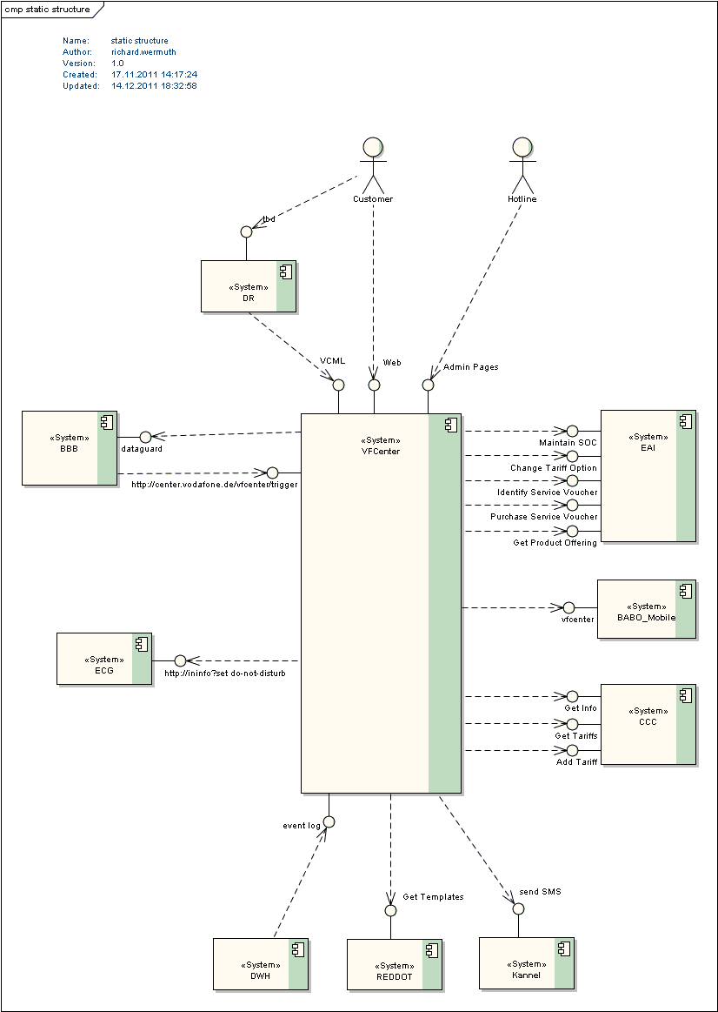

**DR** :Direct Renderer = convert XML to html when VfCenter is accessed with a mobile browser

End-User -> DR -> VfCenter -> XML

BBB : Incoming (Trigger) / Outgoing (DnD) Interface

1. BBB -> Trigger -> VfCenter
2. VfCenter -> Dnd -> BBB

**Kannel :** System used to initiate SMS sending

**Backendbox** : Fetches the user information from UR

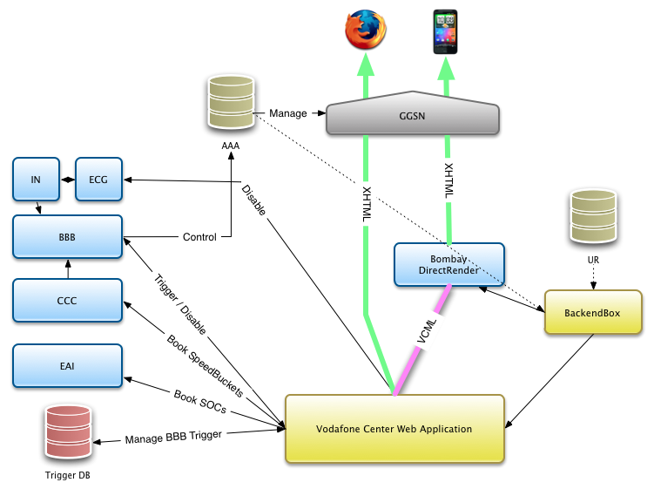

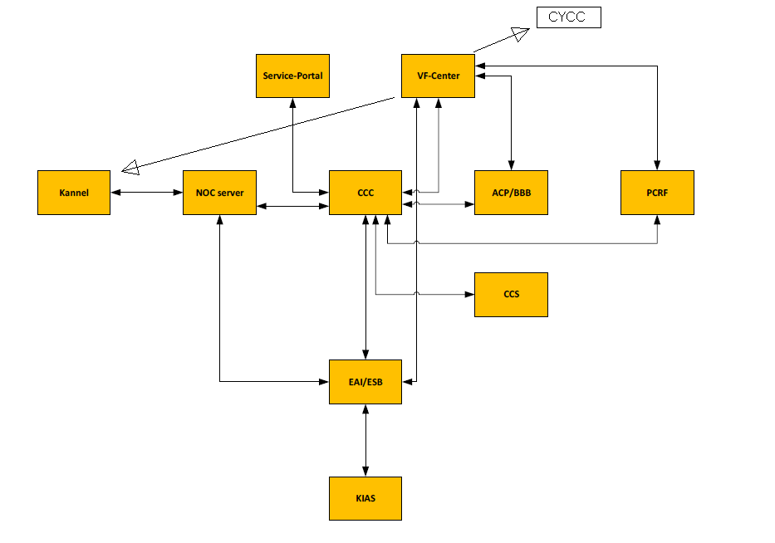

# **2. Testing Environment Setup**

## **2.1 Log configuration**

Host: 192.57.139.110

Port number:- 22

User Name :- stweb1

Password:- Geheim.1

Path: /opt/web/app/tomcat/evfcenter11

## **2.2 Mock configuration**

Follow the below mock configurations for VFCenter:

As part of mock configurations, we changed only the Backendbox response for this particular RMS.

Backend box mock path in WinSCP is as below: /opt/web/app/tomcat/evfcenter11/webapps/simulators/pietz2

Profile.properties : /opt/web/app/tomcat/evfcenter11/conf/vfcenter

It is used to view all the configuration details related to the different profiles in VFCenter

Application.properties : /opt/web/app/tomcat/evfcenter11/conf/vfcenter

Basic configuration file containing all configuration parameters not part of other more specific configuration files. For example, URL to external systems like BBB, PCRF, CCC, BBX, ECG, KANNEL are configured here.

VFCenter URL = http://evfcenter11.stweb.elabs.svcs.entsvcs.net/vfcenter/index.html

Log Configuration path : /opt/web/app/tomcat/evfcenter11/logs

# **ALM path for RMS**

Test Lab Path:

Root>>Post handover>>VF CENTER

# **4. Use Case:**

## **4.1** **VFCENTER_US1**

A “Störer“ text banner has to be implemented on the start screen of VF Center at the upper screen.

Based on the KT Provided by the MPHASIS Team on the RMS174353_VAT_Adaptions_VFC_IDDv1.0, added the functional understanding from our end.

As part of the KT, testing activities performed for RMS174353_VAT_Adaptions_VFC_IDDv1.0 was shown.

Overall, We have 5 Html Profiles and 4 VCML Profiles each has different soc patterns for this RMS this is relevant for the mobile and desktop view.

Profile views for vf/vcmlCreditUpsellSOC, vf/htmlLTEZuhause were demonstrated during the KT ,All other use cases have been executed and following are the results with details.

### **4.1.1 HTML template vf/htmlLTEZuhause:**

soc pattern is ST_HLTEZ

Mock Preparation:

**Step1:** Update the values of vfcid and vfsvcwhite in “backendbox_msisdn_491720499903.properties” with the particular msisdn in filename.

Vfcid with MMC and vfscwhite with ST_HLTEZ.

Path : Backend box: /opt/web/app/tomcat/evfcenter11/webapps/simulators/pietz2

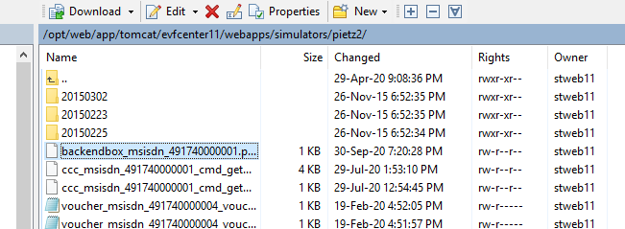

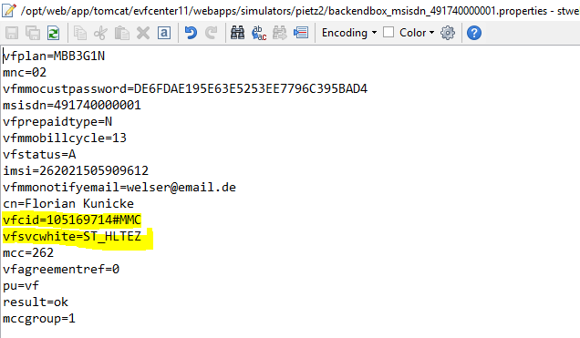

**Step 2:** Open Browser→http://evfcenter11.stweb.elabs.svcs.entsvcs.net/vfcenter/index.html (VF Center can be accessed through only eweb11 Env)

Hit the above URL, User will be navigated to the particular VF center webpage based on his profile.

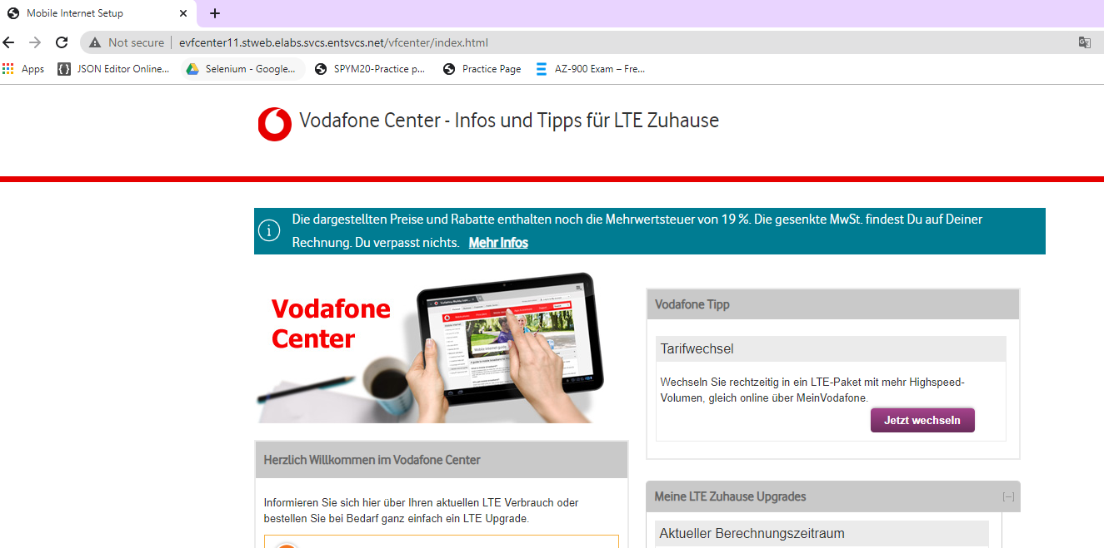

**Log Verification:**

Vfcenter log= /WEB_DATA/var/tomcat/evfcenter11/logs

verify the vfcenter-main.log in winscp in above mentioned path.

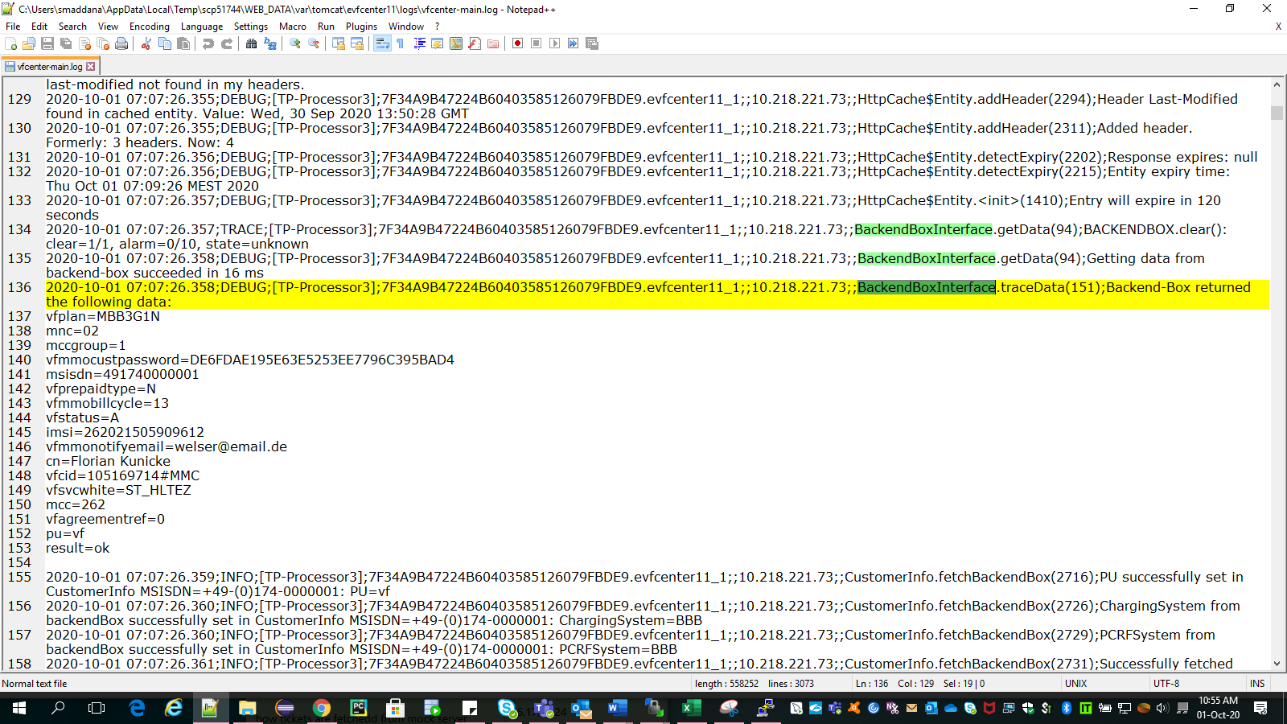

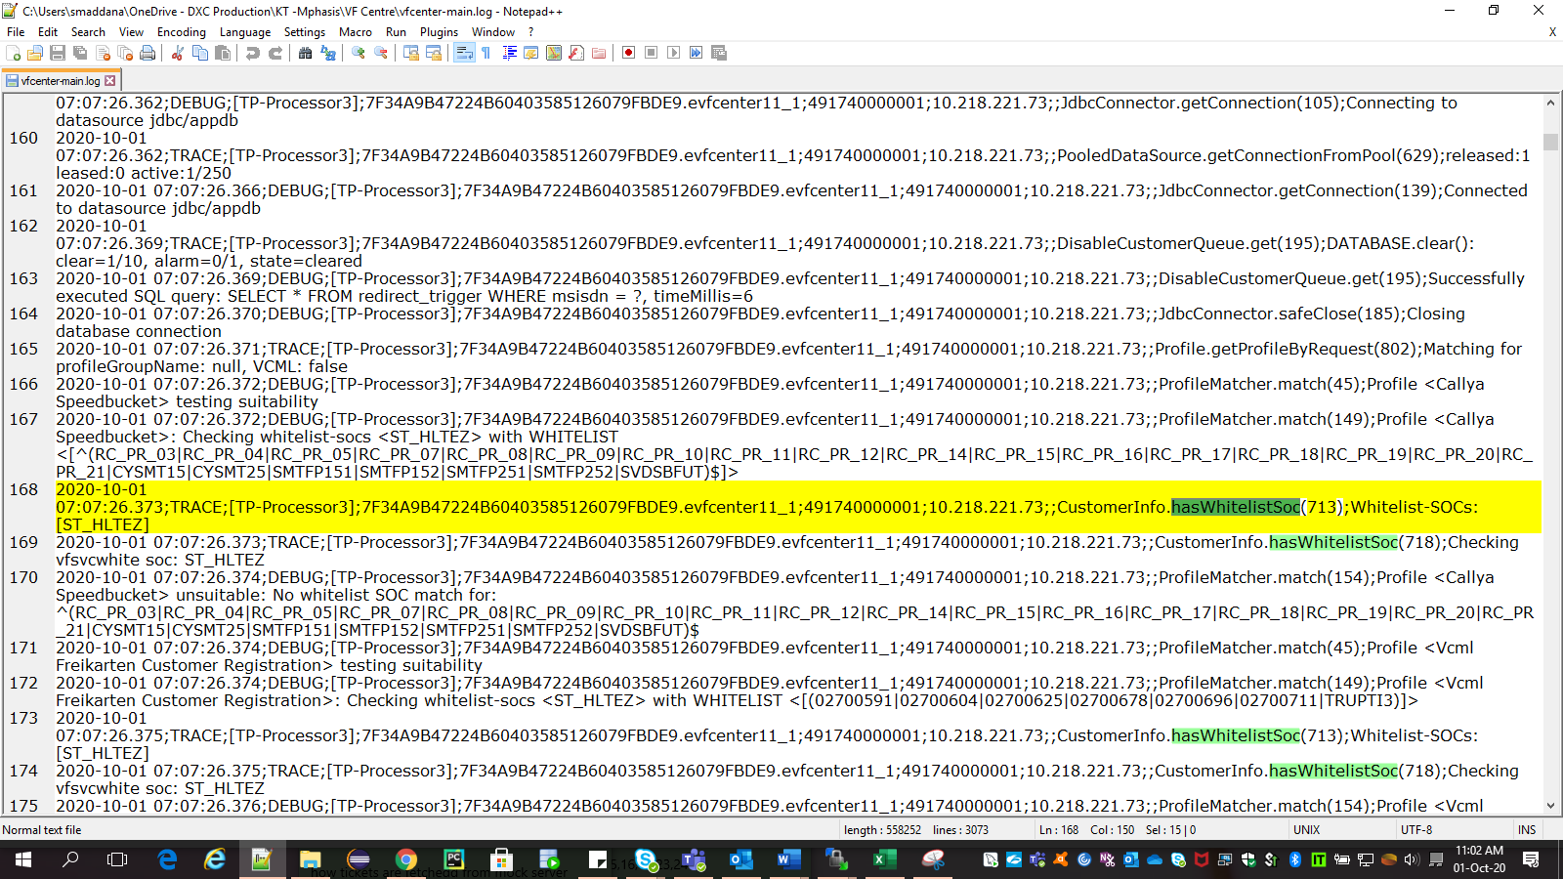

### **4.1.2 HTML template vf/htmlCreditUpsellSB:**

soc pattern is ST_HCUSB

Mock Preparation:

**Step 1:**Update the values of vfcid and vfsvcwhite in “backendbox_msisdn_491720499903.properties” with the particular msisdn in filename.

Vfcid with MMC and vfscwhite with ST_HCUSB.

**Step 2:** Open Browser→http://evfcenter11.stweb.elabs.svcs.entsvcs.net/vfcenter/index.html (VF Center can be accessed through only eweb11 Env)

Hit the above URL, User will be navigated to the particular VF center webpage based on his profile.

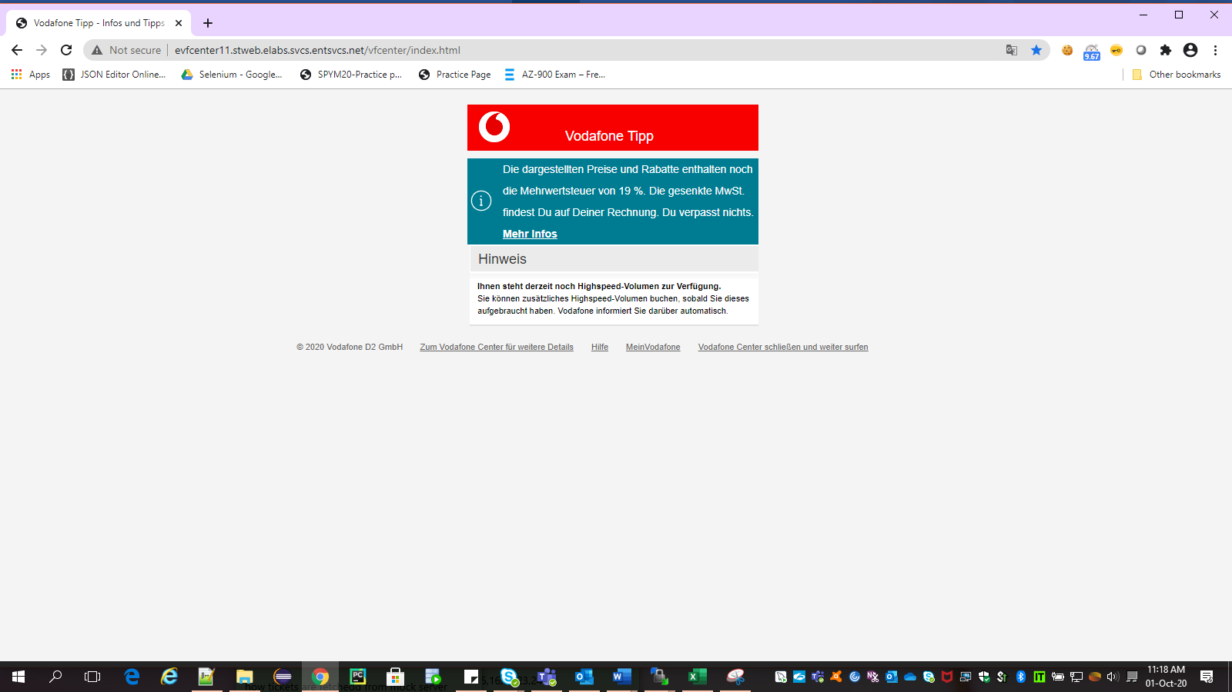

**Log verification:**

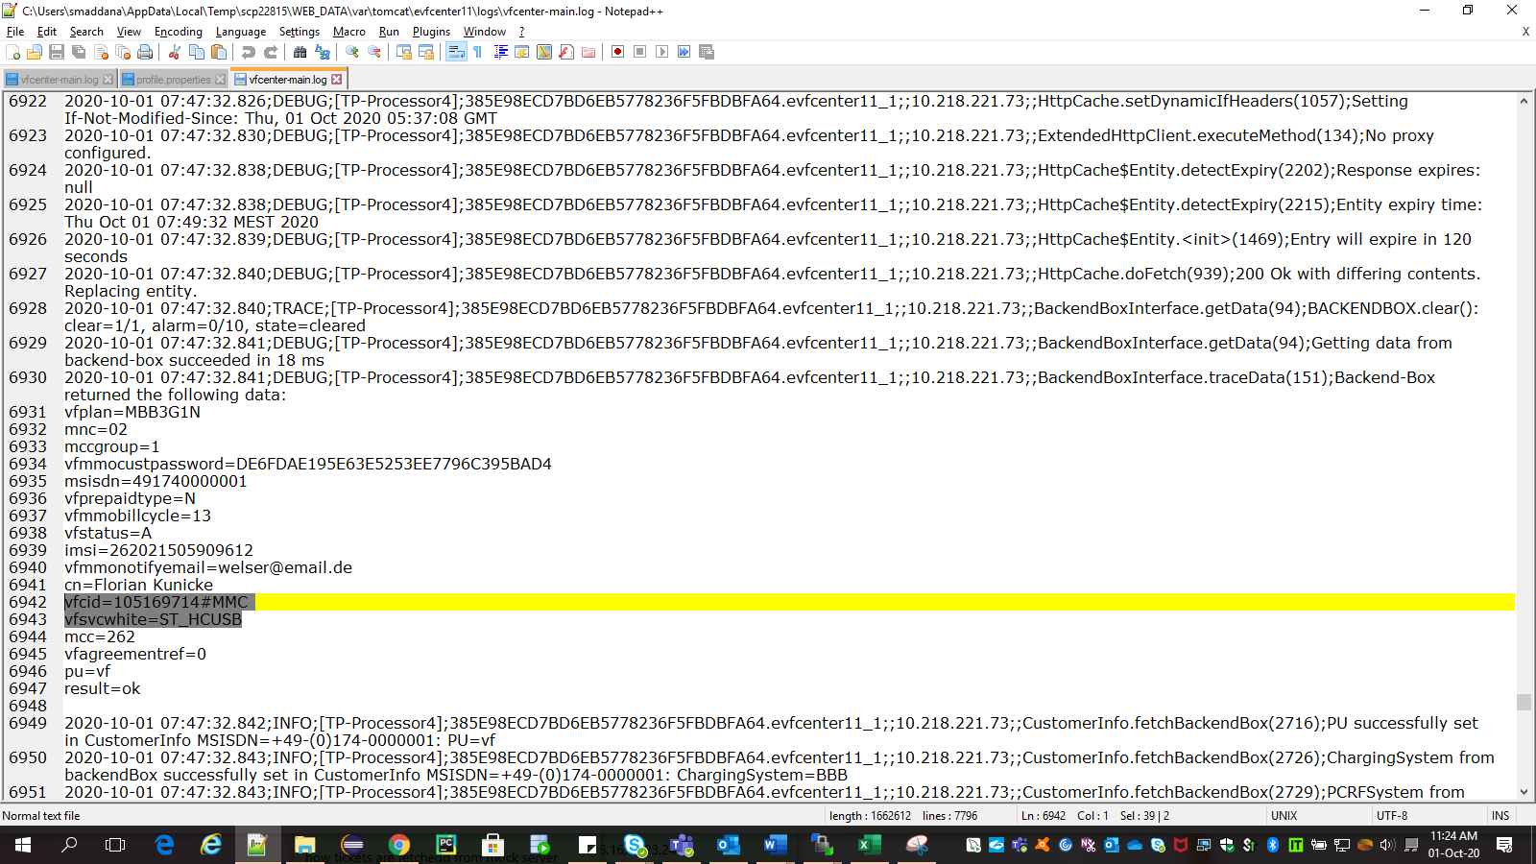

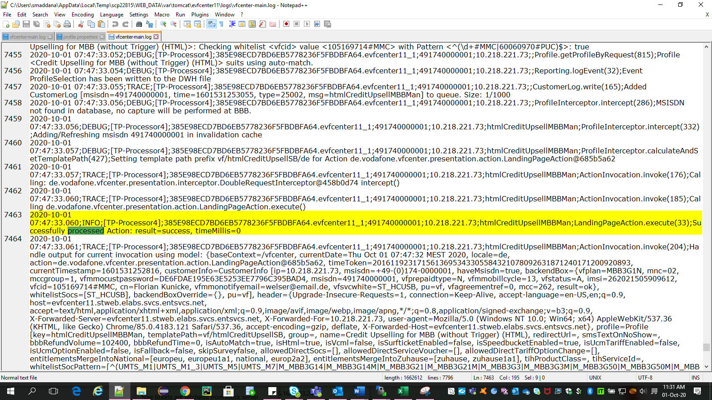

### **4.1.3 HTML template vf/htmlCreditUpsellSOC**:

soc pattern is ST_HCUSOC

Mock Preparation:

**Step1:** Update the values of vfcid and vfsvcwhite in “backendbox_msisdn_491740000001.properties” with the particular msisdn in filename.

Vfcid with MMC and vfscwhite with ST_HCUSOC.

**Step 2:** Open Browser→http://evfcenter11.stweb.elabs.svcs.entsvcs.net/vfcenter/index.html (VF Center can be accessed through only eweb11 Env)

Hit the above URL, User will be navigated to the particular VF center webpage based on his profile.

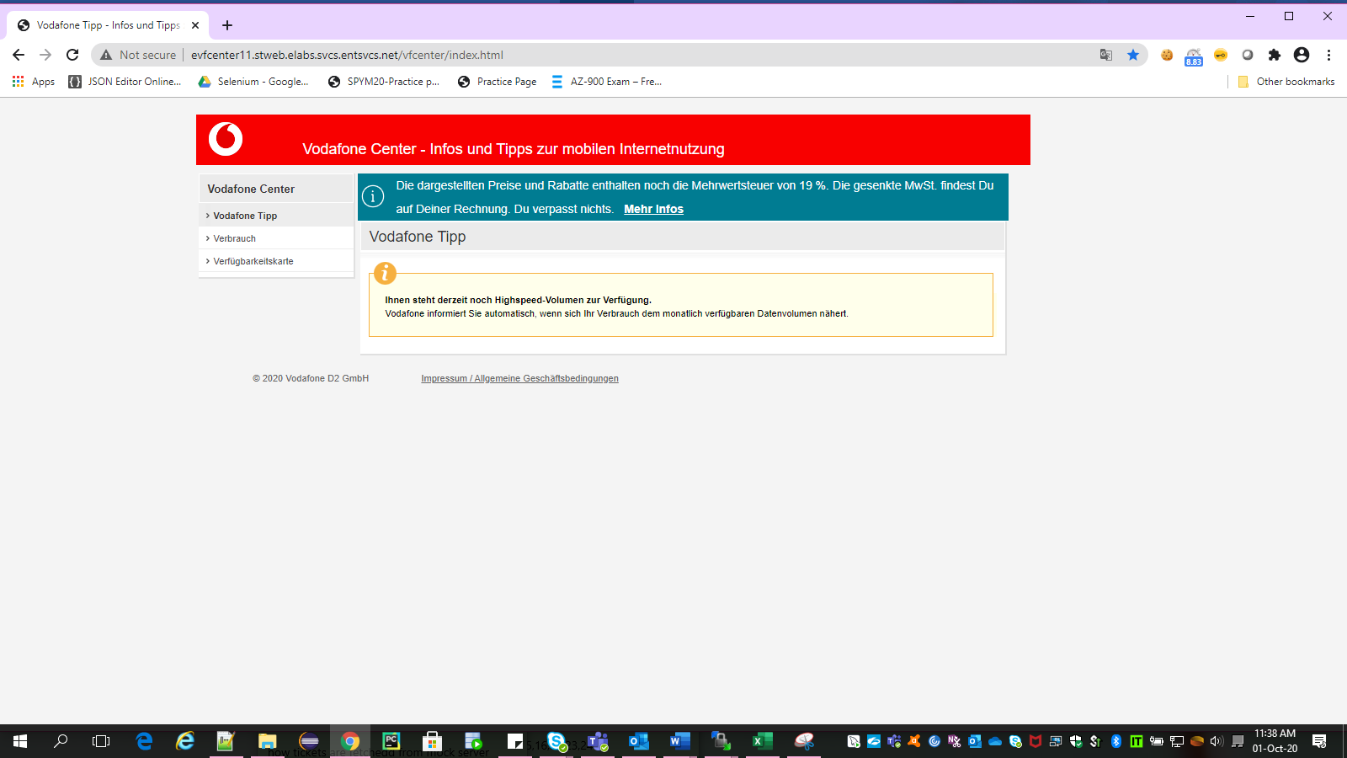

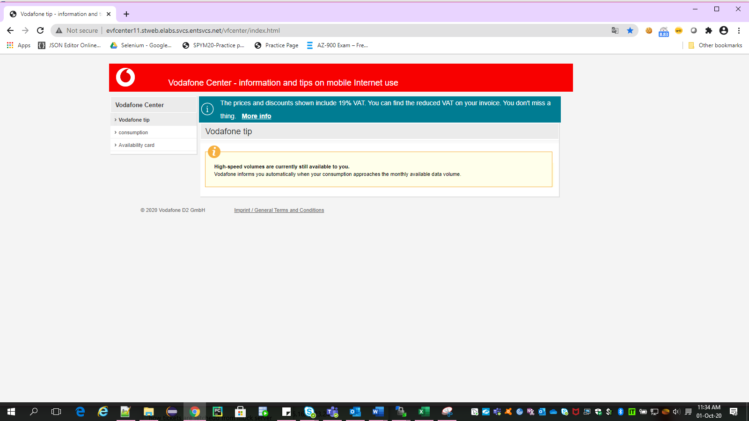

**Log Verification:**

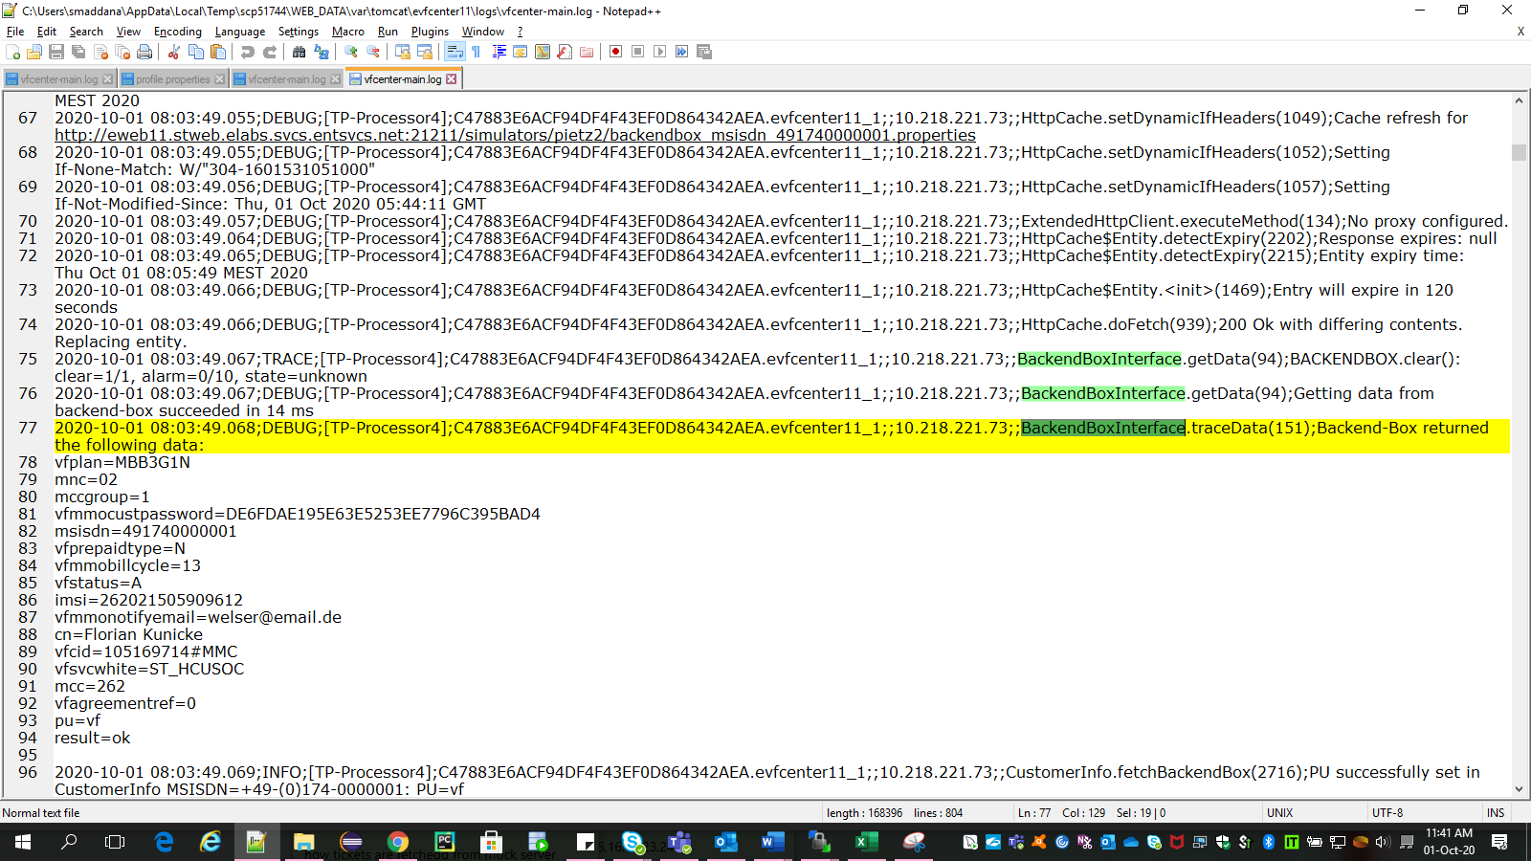

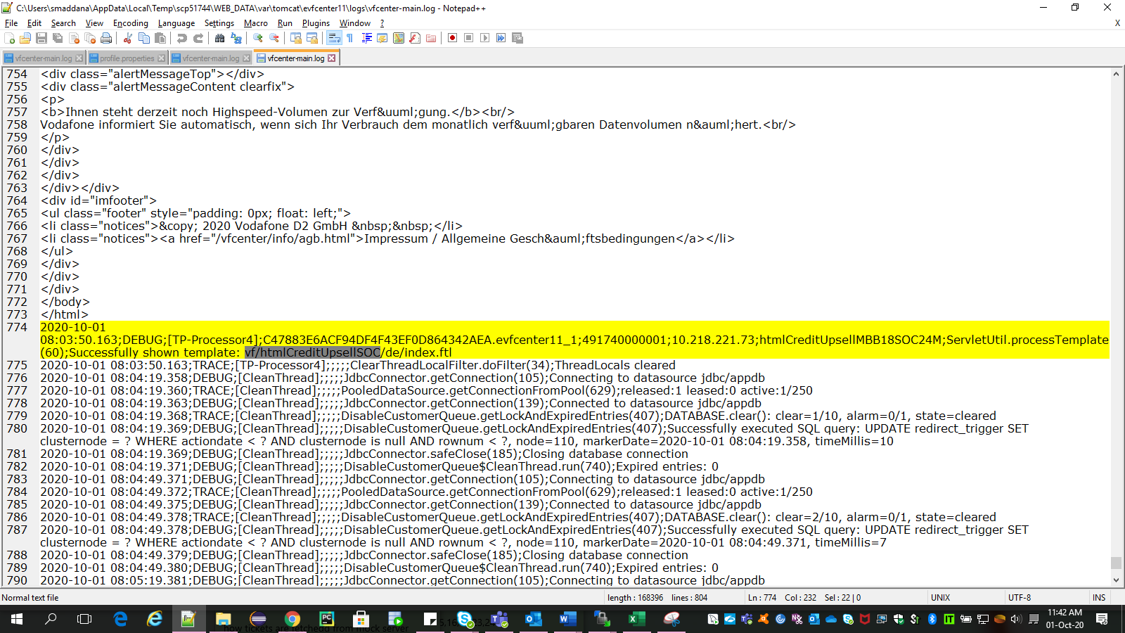

### **4.1.4 HTML template vf/htmlLTEZuhauseRedesign:**

soc pattern is ST_HLTEREDESIGN

Mock Preparation:

**Step 1:**Update the values of vfcid and vfsvcwhite in “backendbox_msisdn_491740000001.properties” with the particular msisdn in filename.

Vfcid with PUC and vfscwhite with ST_HLTEREDESIGN.

**Step 2:** Open Browser→http://evfcenter11.stweb.elabs.svcs.entsvcs.net/vfcenter/index.html (VF Center can be accessed through only eweb11 Env)

Hit the above URL, User will be navigated to the particular VF center webpage based on his profile.

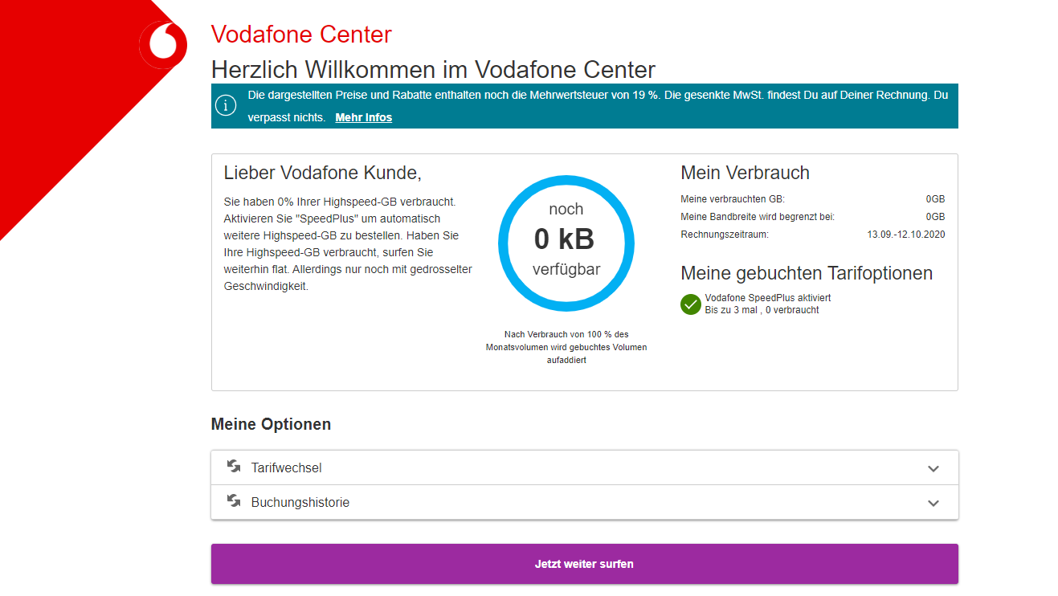

**Log Verification:**

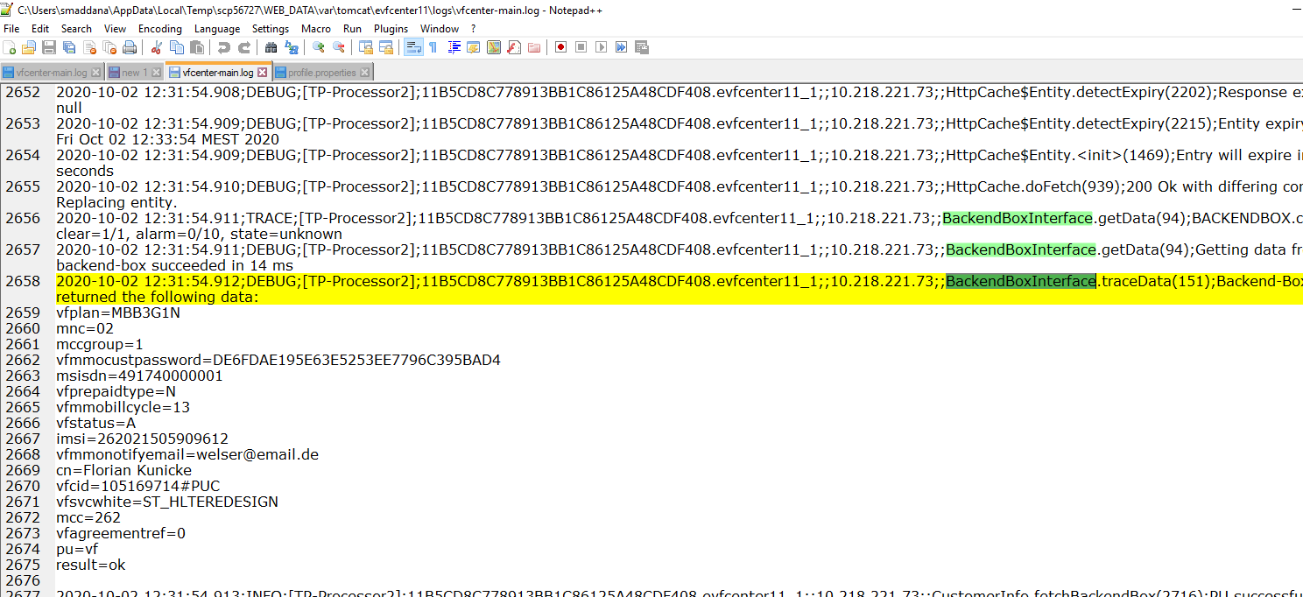

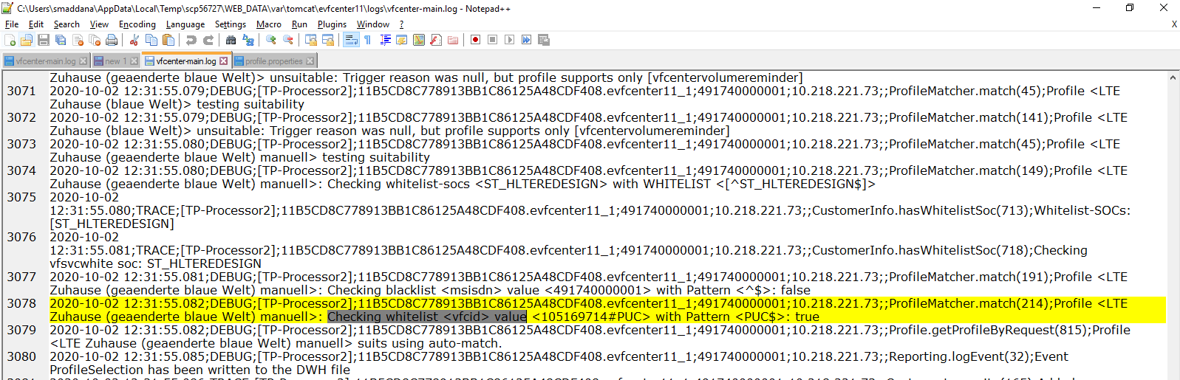

### **4.1.5.HTML template vf/htmlCreditUpsellTariff:**

soc pattern is ST_HCUTARIFF

Mock Preparation:

**Step 1:**Update the values of vfcid and vfsvcwhite in “backendbox_msisdn_491740000001.properties” with the particular msisdn in filename.

Vfcid with MMC and vfscwhite with ST_HCUTARIFF.

**Step 2:** Open Browser→http://evfcenter11.stweb.elabs.svcs.entsvcs.net/vfcenter/index.html (VF Center can be accessed through only eweb11 Env)

Hit the above URL, User will be navigated to the particular VF center webpage based on his profile.

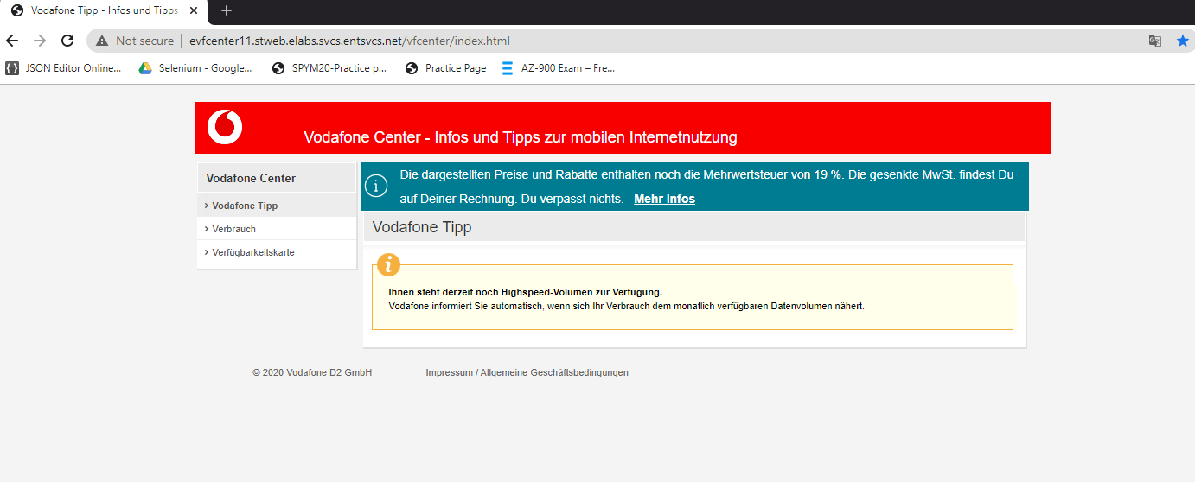

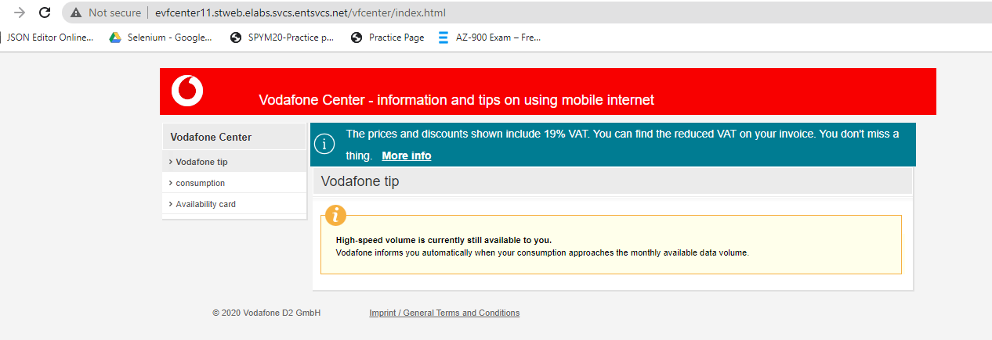

**Log Verification:**

Verify the logs in winscp

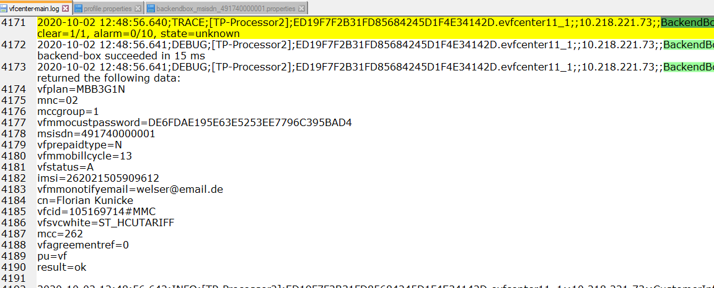

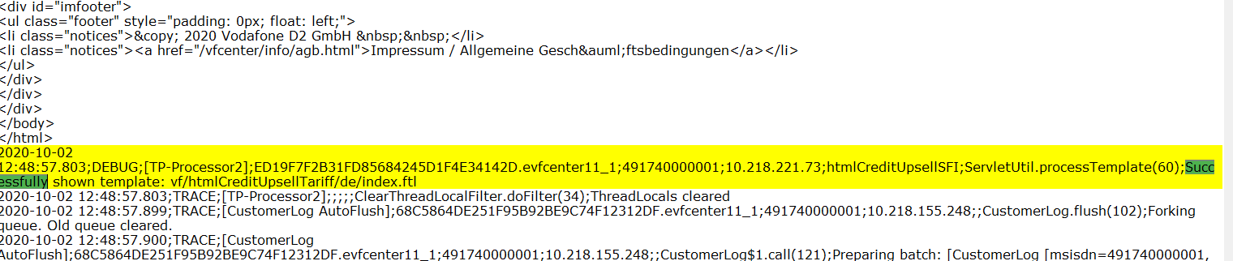

### **4.1.6 VCML template** **vf/vcmlCreditUpsellSB:**

soc pattern is ST_VCUSB

**Mock Preparation:**

**Step 1:**Update the values of vfcid and vfsvcwhite in “backendbox_msisdn_491740000001.properties” with the particular msisdn in filename.

Vfcid with MMC and vfscwhite with ST_VCUSB.

**Step 2:** Open Browser→http://evfcenter11.stweb.elabs.svcs.entsvcs.net/vfcenter/index.html (VF Center can be accessed through only eweb11 Env)

Hit the above URL, User will be navigated to the particular VF center webpage based on his profile.

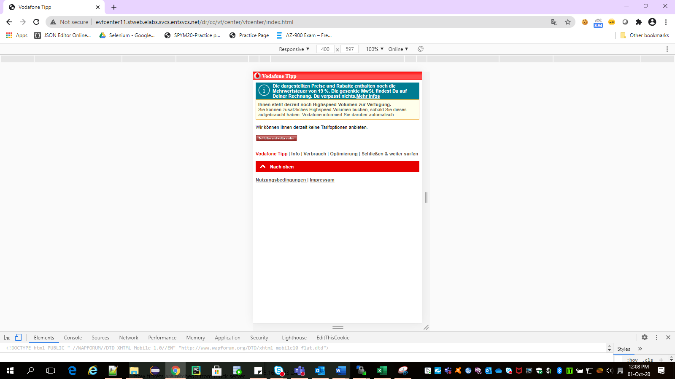

### **4.1.7 VCML template vf/vcmlCreditUpsellTariff**:

soc pattern is ST_VCUTARIFF

Mock Preparation:

**Step 1:**Update the values of vfcid and vfsvcwhite in “backendbox_msisdn_491740000001.properties” with the particular msisdn in filename.

Vfcid with MMC and vfscwhite with ST_VCUTARIFF.

**Step 2:** Open Browser→http://evfcenter11.stweb.elabs.svcs.entsvcs.net/vfcenter/index.html (VF Center can be accessed through only eweb11 Env)

Hit the above URL, User will be navigated to the particular VF center webpage based on his profile.

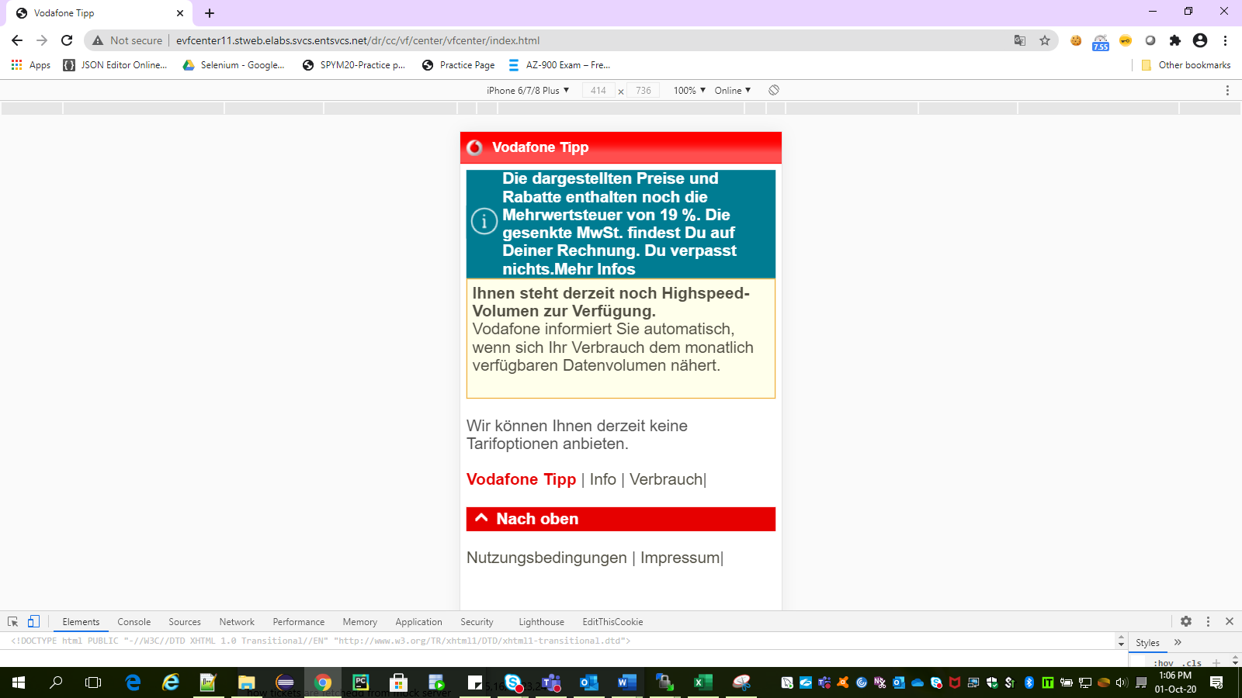

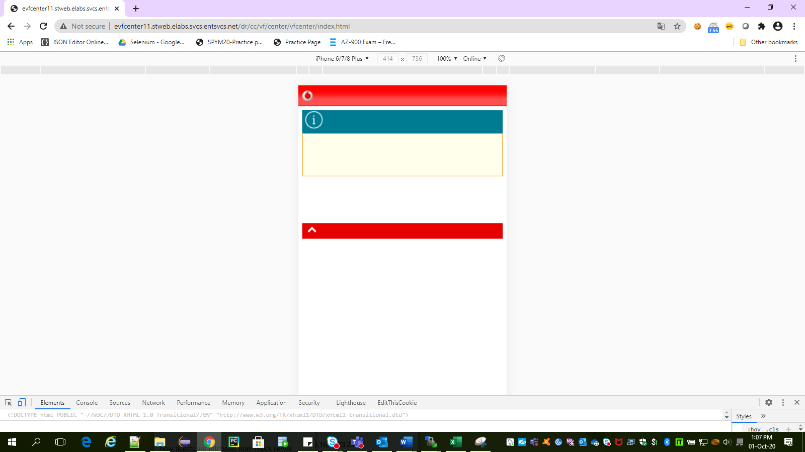

**Log verification:**

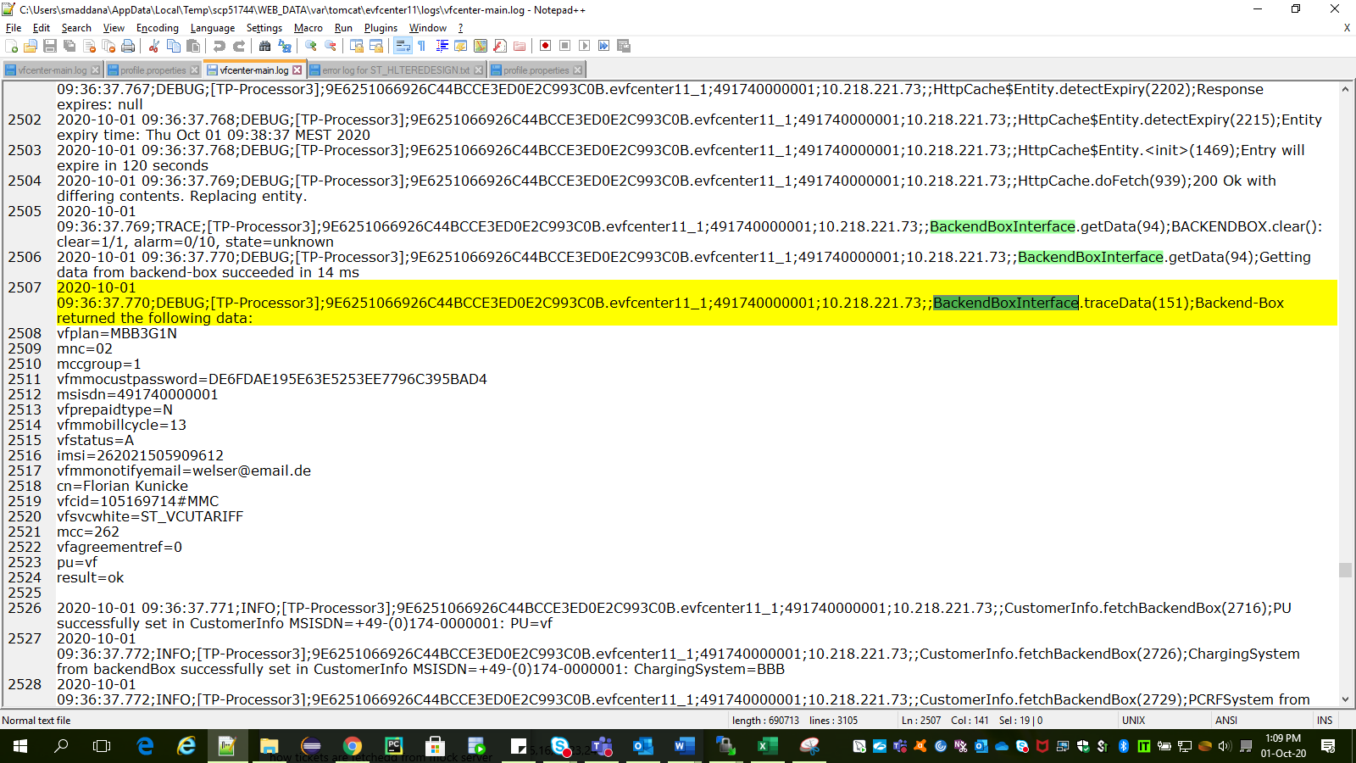

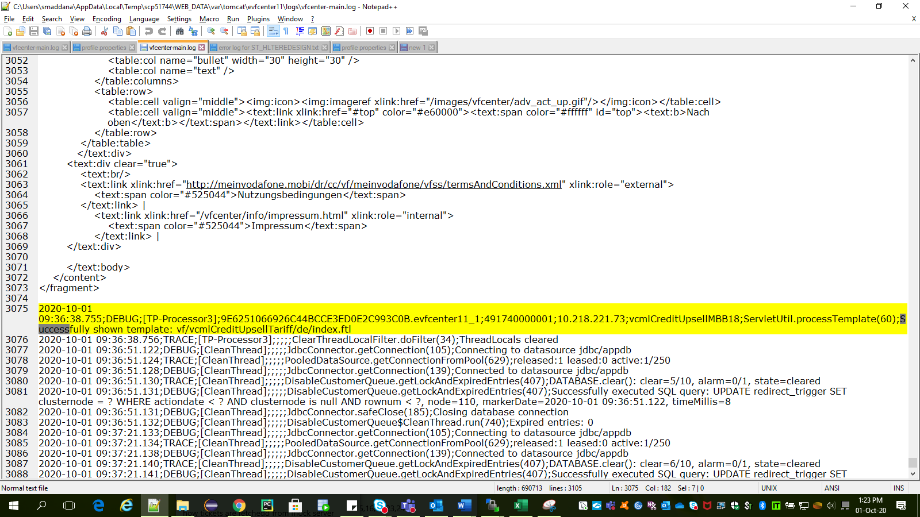

### **4.1.8 VCML template vf/vcmlLTEZuhause:**

Soc pattern is ST_VLTEZ

Mock Preparation:

**Step 1:**Update the values of vfcid and vfsvcwhite in “backendbox_msisdn_491740000001.properties” with the particular msisdn in filename.

Vfcid with MMC and vfscwhite with ST_VLTEZ.

**Step 2:** Open Browser→http://evfcenter11.stweb.elabs.svcs.entsvcs.net/vfcenter/index.html (VF Center can be accessed through only eweb11 Env)

Hit the above URL, User will be navigated to the particular VF center webpage based on his profile.

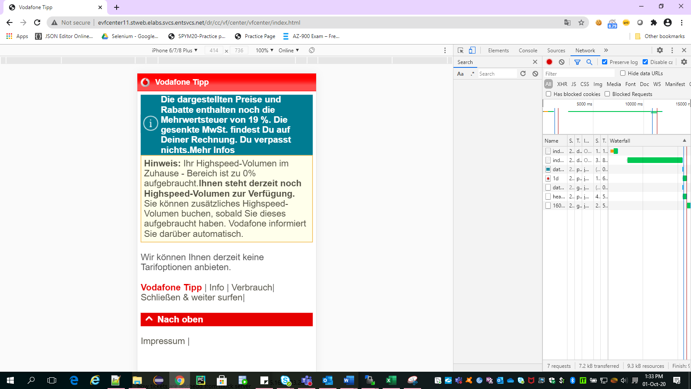

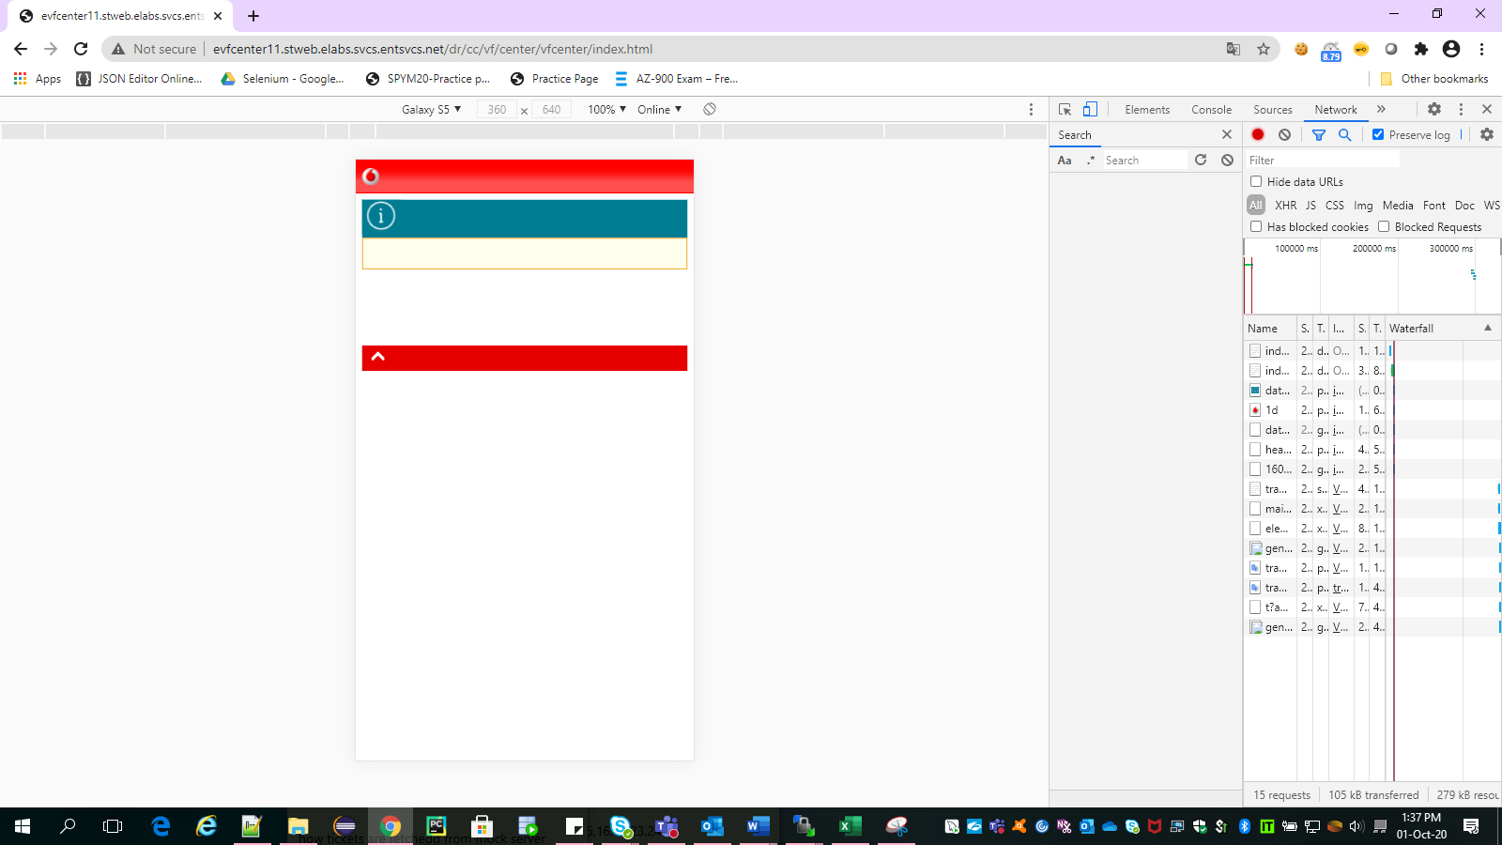

**Log verification:**

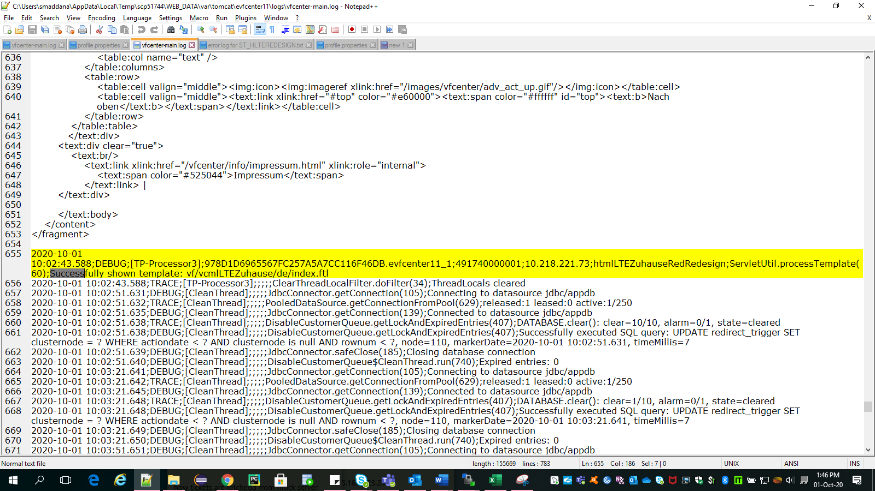

### **4.1.9 VCML template vf/vcmlCreditUpsellSOC**:

Soc pattern is BRNDLIDL

Mock Preparation:

**Step 1:**Update the values of vfcid and vfsvcwhite in “backendbox_msisdn_491740000001.properties” with the particular msisdn in filename.

Vfcid with MMO or PUA and vfscwhite with BRNDLIDL.

**Step 2:** Open Browser→http://evfcenter11.stweb.elabs.svcs.entsvcs.net/vfcenter/index.html (VF Center can be accessed through only eweb11 Env)

Hit the above URL, User will be navigated to the particular VF center webpage based on his profile.

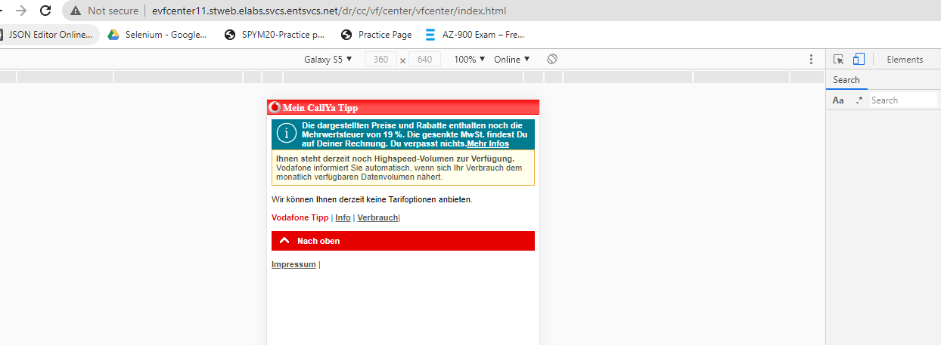

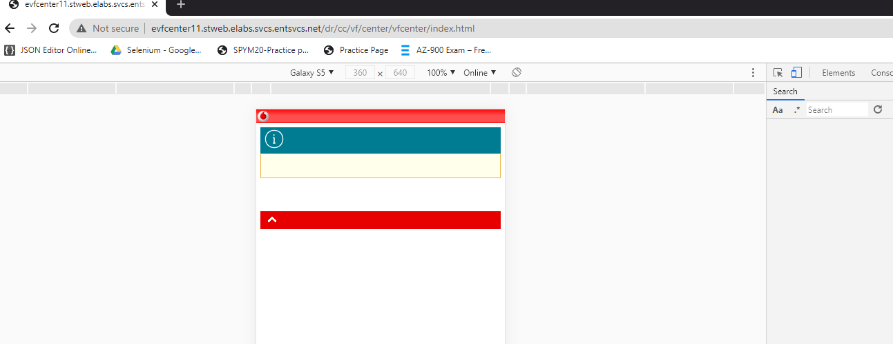

Log verification:

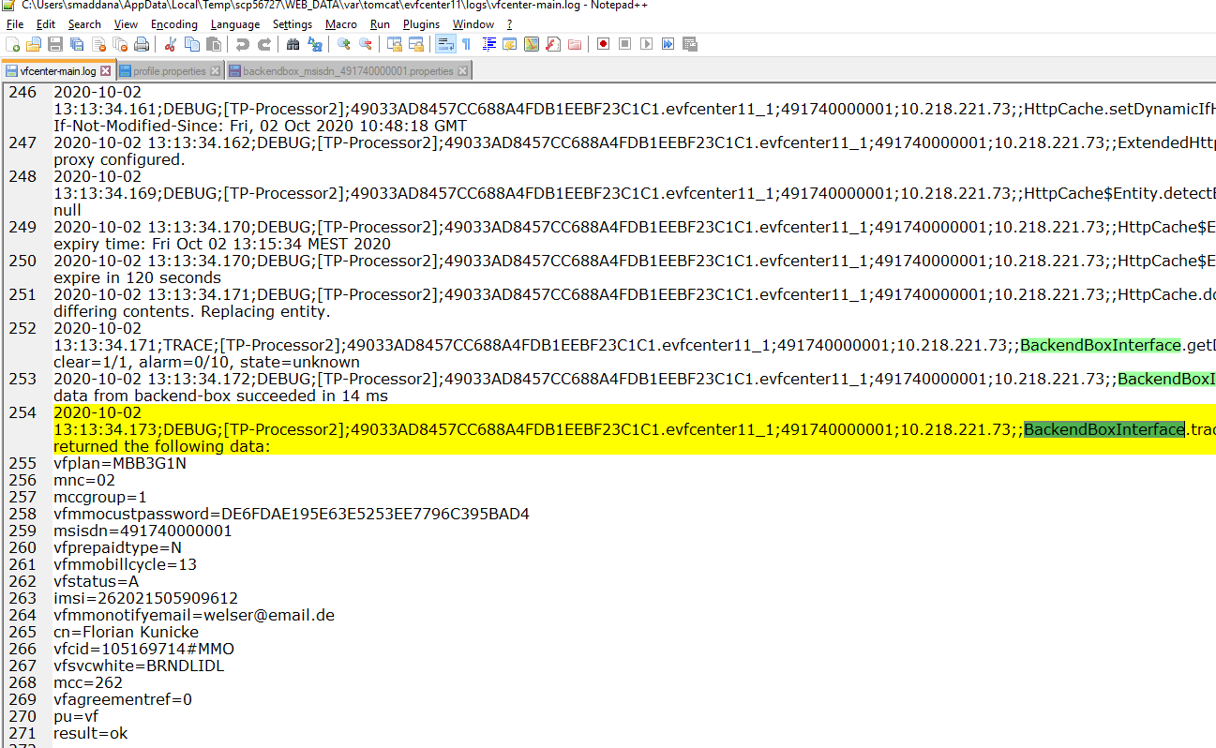

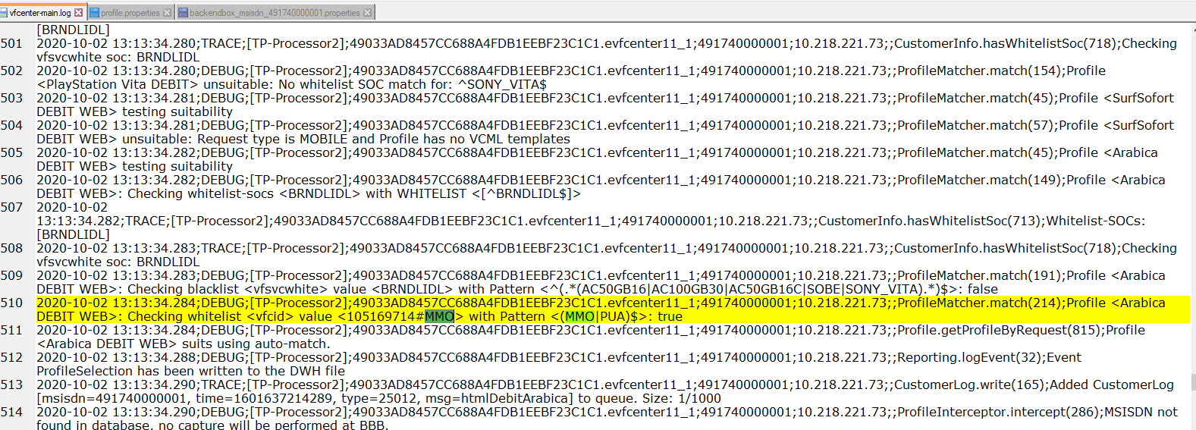

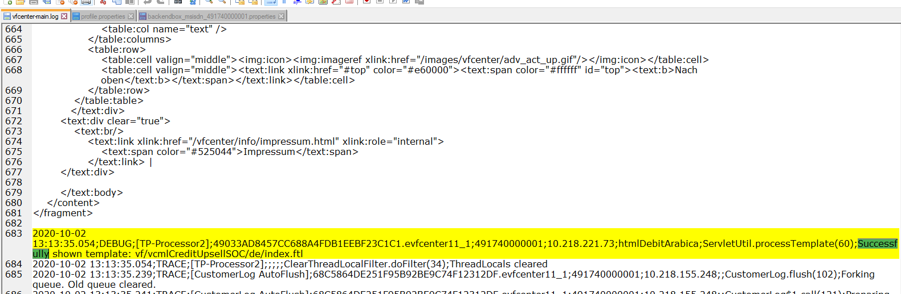

# **5.** **RMS Testing Process**

Recent RMS done are: RMS174353_VAT_Adaptions_VFC_IDDv1.0.docx.

## **5.1 Requirement Analysis and Feasibility**

The Lead / BA will apprise team of Requirements from the Clients in the SDD.The Development and Test Team analyzes the requirements from the SDD among themselves and their implementation or feasibility. The BA/ Lead will Clarify Any Queries from DEV/ TEST.

## **5.2 Test Estimation**

The Test Team will come up with High Level Scenarios, find out any Test Data Requirements for the Scenarios Discuss with Dev and based on the Development Estimation and complexity of the High-Level Scenarios (Complex, High, Medium & Simple) provide an Estimation.

## **5.3 Test Scenario Identification**

Below Procedures are followed

* + Review or Refine High level scenarios. (HLS) by referring to SDD /IDD.
  + Write Test Cases based on HLS and Send to BA/VF SPOC to get it reviewed.
  + Discuss and Request any MOCK Changes from DEV (New Mock or Existing Mock).

## **5.4 Test Environment Set Up**

For every RMS there will be an ELABS Test Environment set up by Infra Team. Verify we can access the Test Environment after confirmation of Infra Team.

We need to check whether we can Access the Mock File/ Log File Location via WinSCP /Putty, DB Connection.

Set Up the Properties files with expected value, Mock Files with Required information like Subscriber Details, Market Code, vfscwhite etc.

## **5.5 Test Execution**

* + Once the DEV has prepared the Build and informed the Test Team, Test Team will Raise Deployment Request for Deployment of the Latest Build on the Test Environment.
  + Infra will Deploy the Build in System Test Environment and inform us.
  + Execute the Test for the RMS Based on the ALM Test Cases, Verify & Capture the Results on the UI and Logs for Test Execution. For Any Deviation Inform/ discuss with Development/BA and Raise a Defect in JIRA after clarifications.
  + We need to Pass / Fail any Test in ALM attaching Test Evidences like Screenshots / Logs etc.
  + The Defect is retested after the Developer fixes the Defect and is deployed by Infra Team and related Test Cases are Passed /Failed Based on the Defect Fix.
  + Once Execution of all the Test Cases is completed Test Team need to extract Execution notification from ALM Analysis->Execution notification ->Generate PDF /Word Document
  + Attach this Document and Declare RFA to VF.

# **5. Production Defect Retest**

* VF Raises Production Defects and will be in Noticed Status
* The Test Team will try to Analyze/Reproduce the Issue.
* In case the Issues is **Reproducible**, Test Team will assign it to the Development Team and change JIRA Status to **In Process.**
* Additionally, Test team identifies the Test Scenario to test for the PROD Ticket.
* Dev Team Fixes the issue in the PROD env and the same need to be deployed by Infra
* In case Defect is not Reproducible the Defect is **Rejected** and assigned back to VF.